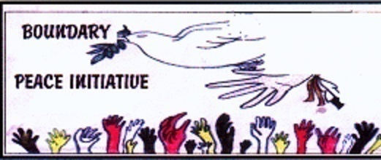
One Year Ends Another Begins
By: Laura Savinkoff, BPI Coordinator
Dear Sisters and Brothers,
As we enter December our minds turn to celebrating Christmas, Hanukah, Solstice, New Years and even the secular world plans for fun times.
It is a time to evaluate where we’ve been in the year past and where we want to be in the year ahead. Depending on your personal understanding how to celebrate, mark or enjoy this time of year will differ and how to view the coming year will also differ. I do feel that we, the people of the world, are striving to find a way to live in peace and harmony with each other and our environment. Yet, for some reason, we continue to focus on what divides us, what separates us.
And then we act on this negative focus by warring, invading, occupying, exercising financial and economic power over ‘the other’, bullying, intimidating, abusing.....and the list goes on and on. This approach creates the chaos and violence in our families, our communities and the world. So many of us want to be right and in the process demand that all agree with what ‘I’ think. This leads to so many of us pulling in so many different directions without stopping to hear and to listen and to look for the common thread.
Where we need to shift our focus is to looking inside ourselves to find what unties all humanity, what is it we the peoples of the world need so as to feel nurtured, loved, valued? And then how can we honour that need? How can we truly nurture and help each other? Does it really take’ power over’ to nurture, to feed, to shelter, to clothe, to value, to support each other? Is it humane, is it honourable, and is it respectful to invade and occupy and steal from others in order to live? Does bullying, abusing, violently insisting create a safe space for peace to grow? What does peace mean? What does living in harmony mean? Does it mean simply a lack of outright war or nation to nation violence or group to group armed conflict? And where does peace begin?
These are the questions that we as humanity need to answer within ourselves and then project that outward into our families, communities. Then this realization will grow to affect corporations and to governing bodies. The realization needs then to translate into focused, concerted action from each one of us. We each have a personal responsibility to live in peace and harmony.
(Continued next column)

Volume 217

Dec. 1, 2021

(From last column) One Year Ends Another Begins
Giving safe space for all of us as individuals, as families, as communities, as nations, as the people of the world to ensure that all are respected, honoured, treated with dignity and kindness, all have food and shelter, clean water, good healthcare, etc...everywhere, all the time, with no distinction of race or religion or gender or sexual orientation or financial status or any of those things that continue to divide us.
Is it possible? Of course it is, if we as a collective truly want it and commit to living, breathing peace.
The last two years have been a challenge for the world as Covid took over our lives and persists in raising its ugly head over and over again; just when we think we have things under control another variant/mutation pops up and we must once again take the extra precautions. And then, once again, the divisions in our communities come to the fore and in some instances have become more pronounced. And that is sad! It is so unnecessary for such anger that has turned to violence and abuse of each other, invaded our friendships, our families, our work places, our communities. It is possible to be respectful of each other’s life choices. There are some measures, whether we agree with them or not, that are required for the ‘greater good’, for the safety and wellbeing of all humanity. But, there is room for personal choice. Ever choice we make has its consequences. When we choose not to support the war machine we are looked askance at by those, the majority, who choose to support the military industrial complex; there are consequences when we wear a White Poppy; there are consequences when we stand up in support of the Palestinian people; there are consequences when we support those standing firm to stop destroying our environment. Personally, I will not support any forms of violence in my work to support this previous list of choices and many others. I support speaking out and asking and at times even demanding that Governments change their outlook, urging our global family to look more closely at these issues and make informed and conscience choices that lead to living in peaceful harmony with Mother Earth and all her inhabitants. The BPI will not act in anger nor will be support violent protest nor will be support any action that does not take into account the well being of our global family, our neighbours near and far.
The Boundary Peace Initiative has and will continue to work to share information that will help us understand the pain and suffering from violence and abuse that surrounds us (Continued page 2)

Boundary Peace Initiative Newsletter—Page 2

(From page 1) One Year Ends Another Begins
whether on the local or global level, for both affect our daily lives. We also have and will continue to share the positive works and suggestions from all over the world from people who give of themselves to get to that place of peace and harmony, honour and respect with and for all that exists on Mother Earth. We will continue to urge and encourage all to put aside the prevailing attitude of ‘might is right’, that race, religion, financial or social status determines how we treat our neighbours, our global family.
We take this time to thank you for your ongoing support and interest. We look forward to working with you in 2022. We look forward to the time when we will once again be in a position to organize events and conferences without Covid restrictions.
In Universal Kinship and Loving Peace let’s join hands, hearts, and minds to bring unity in diversity, in harmony with all that exists.
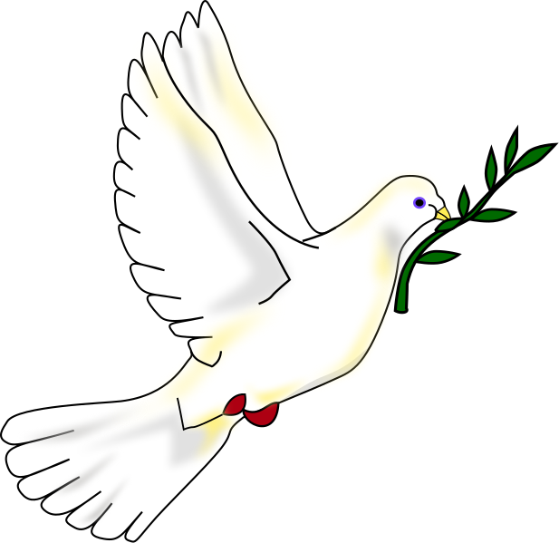

- Men at

(From last column) Reflections on Indigenous peoples
Talaga recounts the stories of Aboriginal teens from remote communities in northern Ontario who travel hundreds of kilometres from their homes to Thunder Bay to attend high school because there is no alternative if they wish to continue their education. These are children, as young as fourteen years old, who travel bravely from small villages to a large city for the first time, to board with families and to negotiate the challenges of city life, with limited support, and with limited life skills. Their travels were frequently punctuated by racism.
As these children walked along sidewalks, unprovoked passersby in cars would regularly scream insults and throw garbage at them. Remember Barbara Kentner, killed in Thunder Bay by someone who threw a trailer hitch at her from a moving vehicle.
Like Barbara, these children started to die. Talaga relates the circumstances of their seven young deaths over a period of years. Had more attention been paid to the early deaths, the later deaths might have been avoided, but reaction was slow presumably because they were Indigenous children. What these seven fallen feathers were doing prior to their deaths was no different than what non-Indigenous children do. The difference is the safety net for non-Indigenous children. People, including the police, in Thunder Bay and other Canadian communities care and watch non-Indigenous children to protect them from their mistakes.
Teens think they're immortal, seek peer acceptance, engage in risky behaviours. It took the death of seven Indigenous children before we noticed this unfolding tragedy, which is shameful, but upon reflection, unsurprising. It took over 1,000 deaths between 1980 and 2012 before we noticed the tragedy of the Missing and Murdered Indigenous Women and Girls. Canada's safety net for Indigenous people is filled with gaping holes.
Talaga describes Indigenous communities in northern Ontario. They often lack clean water and sewage treatment. Housing is decrepit, unsafe, overcrowded. Health and educational services are substandard. Unemployment is high. The communities are overseen by a heavily bureaucratic, under-funded administrative system with responsibilities unclearly divided between the federal and provincial governments. The system fails to provide for Indigenous people at the same standard as non-Indigenous people. These scandalously overlooked holes in the safely net span generations. In spite of the Royal Commission on Aboriginal Peoples, the UN Declaration on the Rights of Indigenous Peoples, Idle No More, the Truth and Reconciliation Commission, the National Report on Murdered and Missing Indigenous Women and Girls, there still isn't consensus on the need, let alone a plan to mend the safety net for Indigenous people.
In the next federal election, I will support candidates with a clear commitment to improve the lives of Canada's Indigenous peoples.

Reflections on Indigenous peoples
By: Robert M. Macrae; Selkirk College, Castlegar, BC
After the release of the Royal Commission on Aboriginal Peoples (1996) report, I began to read more regarding Canada's Indigenous peoples. The RCAP recommended substantive changes to the relationship between Canada's Indigenous and non-Indigenous peoples, to respect (1) Indigenous cultures, (2) Indigenous nationhood, and (3) the inherent right to Indigenous self-determination.
I read Ipperwash: The Tragic Failure of Canada's Aboriginal policy (2013) by Edward J. Hedican, a history of Canada's Indigenous peoples from pre-contact to the present. Hedican, an academic, explains treaties, the legacy of broken promises, residential schools, and events such as the Ipperwash and Oka crises.
I read Keeping the Lakes' Way: Reburial and Re-creation of a Moral World among an Invisible People (1999) by Paula Pryce. Pyrce introduced me to the Sinixt, Indigenous people who live where I live, to their culture and history. She goes far beyond what I knew: the Sinixt were declared extinct in 1956 and therefore lost their legal Indigenous status. The Sinxit recently successfully challenged that decision.
I read We Share our Matter: two centuries of writing and resistance at Six Nations of the Grand River (2014) by Rick Monture, a history of the Haudenosaunee (Mohawk) people. I didn't know this history although I grew up in southern Ontario close to Haudenosaunee reserves.
I read The Inconvenient Indian, Green Grass Running Water, and Indians on Vacation by Thomas King, in part because I was a fan of Thomas King's CBC radio program, Dead Dog Café Comedy Hour. King is Indigenous and an excellent writer. He provides personal and mythic perspectives.
However, it was Seven Fallen Feathers (2017) by Tanya Talaga that crystallized the injustices, the privations and hardships, the intergenerational trauma of Indigenous peoples since European contact - systematic betrayals, theft of their land, destruction of their cultures – colonization and genocide.
(Continued next column)

What difference does it make to the dead, the orphans, and the homeless whether the mad destruction is wrought under the name of totalitarianism or under the holy name of liberty or democracy?
Mahatma Gandhi

It is my conviction that killing under the cloak of war is nothing but an act of murder.
Albert Einstein

Boundary Peace Initiative Newsletter—Page 2

Our Mission
The Boundary Peace Initiative represents people of diverse backgrounds officially brought together in 2002 because of our mutual concern for the rise in world conflict. Our mandate is to participate in multilateral non-violent conflict resolution in support of global human rights, ecological and environmental sustainability and international law through education, sharing of information, dialogue and activism locally and globally. We encourage and seek your participation in our mutual work for true peace based on social justice, equality, accountability, integrity, honour, respect, etc in order to build a better world today and future generations.

BPI web site: www.boundarypeaceinitiative.org
For info contact Laura at (250) 444-0524 or (250) 442-0434 or email: L4peace@telus.net.

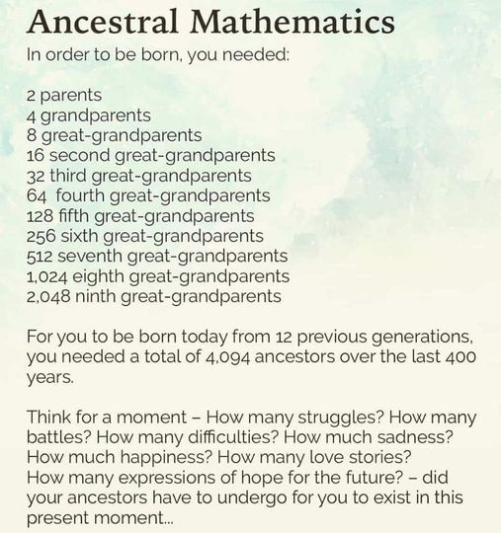
Submitted by Walter Hoodicoff

2021 Right Livelihood Awards go to community leaders against violence and climate change
Basel Peace Office congratulates the amazing winners of the 2021 Right Livelihood Award, also known as the 'Alternative Nobel Peace Prize' who were announced today {Ed. Note: Sept. 29}. And we invite you to Nonviolence in the 21st Century (La non-violence au 21ème siècle), an event on October 2, the International Day of Nonviolence, with some of the previous winners of the Right Livelihood Award as speakers. (Event will have simultaneous translation in English/French).
Marthe Wandou (Cameroon)
For building a model of community-based child protection in the face of terrorist insurgency and gender-based violence in the Lake Chad region of Cameroon.

Vladimir Slivyak (Russia)
For his defence of the environment and for helping to ignite grassroots opposition to the coal and nuclear industries in Russia.

Freda Huson (of the Wet’suwet’en people, Canada)
For her fearless dedication to reclaiming her people’s culture and defending their land against disastrous pipeline projects.

Legal Initiative for Forest and Environment (India)
For their innovative legal work empowering communities to protect their resources in the pursuit of environmental democracy in India.

United Nations International Days of Action
Below are the dates that relate to the work of the BPI.

Dec. 1: World Aids Day
Dec 2: International Day for the Abolition of Slavery (A/RES/317(IV))
Dec 3: International Day of Persons with Disabilities (A/RES/47/3)
Dec. 9: International Day of Commemoration and Dignity of the Victims of the Crime of Genocide and of the Prevention of this Crime ( A/RES/69/323)
Dec 10: Human Rights Day (A/RES/423 (V))
Dec 18: International Migrants Day (A/RES/55/93)
Dec 20: International Human Solidarity Day (A/RES/60/209)


Packaging White Poppies at the Peace Pledge Union in London, UK—Oct. 2019

Boundary Peace Initiative Newsletter—Page 3

WHAT’S UP?
May you all have a wonderful holiday season whether Christmas, Hanukah, or any other tradition. Thank you for your ongoing support as we work together to create a better world for all humanity and learn to value each other and our planet.

War is a racket. It always has been. It is possibly the oldest, easily the most profitable, surely the most vicious….It is the only one in which the profits are reckoned in dollars and the losses in lives.
US Major General Smedely Butler

The higher the opinion a person has of himself, the more unstable is his position; the lower he moves in his self-esteem, the firmer he stands. Leo Tolstoy

Russia-USA Strategic Stability Dialogue--NO FIRST USE
From: PEOPLE FOR NUCLEAR DISARMAMENT; HUMAN SURVIVAL PROJECT: ZONA LIBRE: WORLD FUTURE COUNCIL: ABOLITION 2000 NUCLEAR RISK REDUCTION WORKING GROUP
July 19, 2021
Mr Joseph Biden President of the United States of America,
Mr Vladimir Putin President of the Russian Federation, Delegates to Strategic Stability Dialogue
Dear President Biden and President Putin,
Dear Delegates to the Strategic Stability Dialogue
We commend you for adopting the U.S.-Russia Presidential Joint Statement on Strategic Stability, in which you affirmed that 'a nuclear war cannot be won and must never be fought', and by which you established an integrated bilateral Strategic Stability Dialogue to lay the groundwork for future arms control and risk reduction measures
We welcome the commencement of the Integrated Bilateral Strategic Stability Dialogue, the first meeting of which we understand may take place this week.
We recall and draw your attention to the Open Letter sent to you prior to the June 16 Summit endorsed by over 1200 highly distinguished persons including legislators, religious leaders, civil society leaders and former government leaders (prime ministers, ministers of foreign affairs and defence, diplomats and senior military personnel). The Open Letter expresses the same understanding as in your Joint Statement, that a nuclear war cannot be won and must never be fought, and it calls for the implementation of this understanding through the adoption and implementation of nuclear-risk-reduction measures, the most important of these being the adoption of No-First-Use policies.
In strict logic, if no one 'fires first' with a nuclear weapon, as No-First-Use implies, then the war that 'cannot be won and must never be fought' cannot take place. Whatever caveats might be added to that (accidental launch, miscalculation, malware, etc), it is clear that a commitment to No-First-Use, does at least make escalation to nuclear war much much less likely.
To date, India and China have adopted unilateral No-First-Use policies. Russia and China have adopted a mutual No-First-Use agreement. It is notable that when Indian and Chinese troops fought over parts of Tibet/Ladakh, escalation to nuclear war was not threatened or implied by either side. In contrast, when Russian and US/NATO forces face each other across Baltic or Ukrainian or Black Sea borders, escalation to a nuclear crisis or even nuclear war is not ruled out and remains a frightening possibility.
Regardless of whether or not the various conflicts between USA and Russia can be suitably managed or resolved in the short to medium term, the risks of nuclear confrontation need to be reduced, strategic stability restored and progress on arms control and disarmament achieved. This is the fundamental purpose of your Strategic Dialogue, which is of benefit not only to the Russian Federation and the USA, but to the entire world.
No-First-Use, and the closely related 'sole purpose' policy option, (that the sole purpose of nuclear weapons use is to prevent other nuclear weapons use), are not of course, the only measures that can be taken to lower the risk of nuclear war, whether started by conflict escalation or accident. A range of measures can be taken that include de-alerting, data-sharing, and avoidance of provocative exercises near each other’s borders with nuclear-capable forces. All of these measures will be facilitated by a posture of No-First-Use.
A full menu of nuclear risk reduction measures may be found on the website of the Abolition 2000 nuclear risk reduction working group:
Of particular relevance is a Letter to President Biden from Dec 2020, canvassing risk reduction measures including No-First-Use (and urging strategic dialogue), that could be profitably discussed in a strategic stability dialogue.
However, out of all these worthy measures, No-First-Use is, hopefully, something that the Russian Federation and the United States of America can find or create the political space and the will upon which to agree.
The world has been a little too close to the brink recently. Anything that a Strategic Stability Dialogue can do to take us back from that brink is most welcome and we therefore wish the very best for this very important process.

Signed: John Hallam; Alyn Ware; Aaron Tovish; Prof. Frank Hutchinson

The BPI welcomes your input. Articles may not be common consensus of members. To submit articles contact Laura at 250-444-0524 or 250-442-0434 or email L4peace@telus.net.

The BPI is an affiliate of the Fellowship of Reconciliation, Peace Pledge Union, Stop Ecocide Canada, Abolition 2000 & CNANW and works with local and global peace, social justice and environmental groups.

Voice your opinion to the Prime Minister and all MPs. Free postage: {Name of MP}, Parliament Buildings, Ottawa, Ontario, K1A 0A6
Go to the Government of Canada website for MP contact information at http://www.canada.gc.ca

Boundary Peace Initiative Newsletter—Page 4

