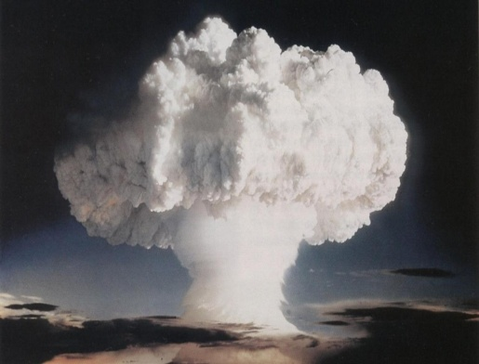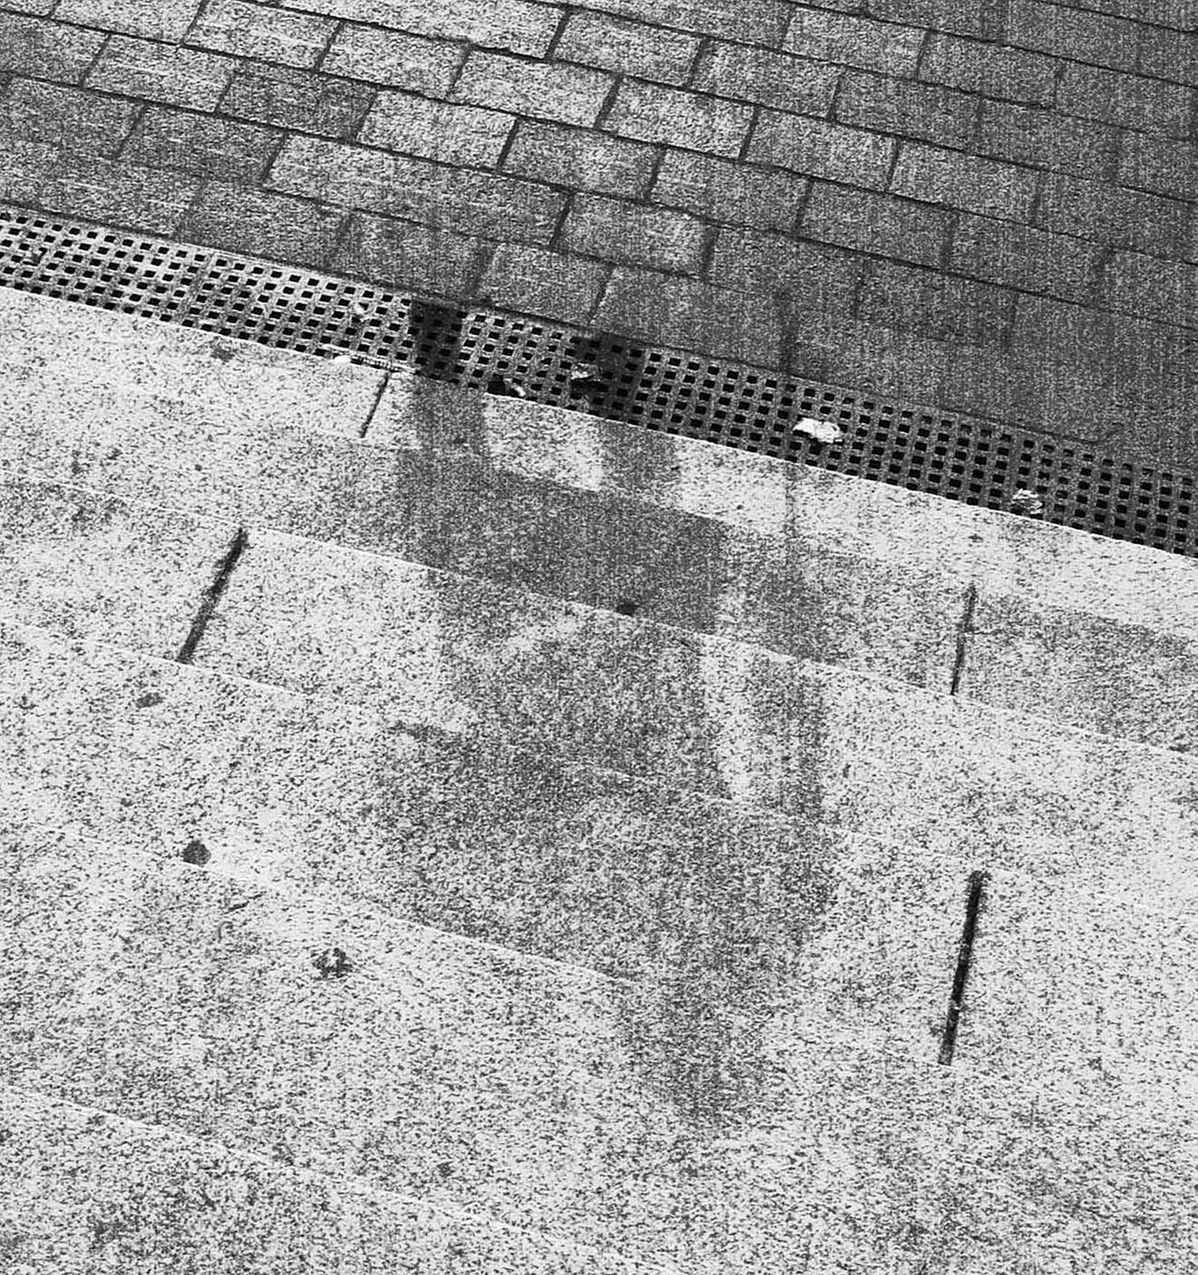
a. The Bomb 1945 b. Vaporized 1945
NAGASAKI DAY
August 9, 2022 @ 6 pm
Gyro Park, Grand Forks
Speakers, Entertainers, Information
Remember and Honour all Victims of
Nuclear and D U Weapons, Nuclear Power accidents like Chernobyl, Fukishima, and Three Mile Island, Uranium mining, leaky radioactive waste.

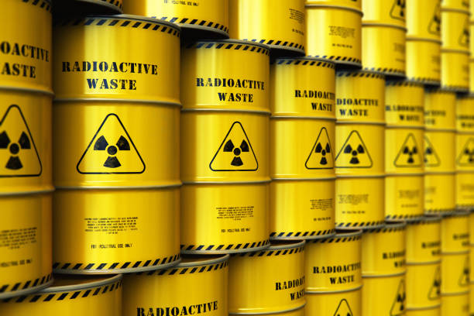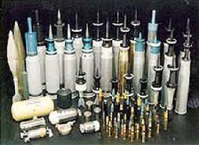
c. Radioactive waste d. D.U Radioactive bullets

Sponsor/Organizer: Boundary Peace Initiative
Supporting groups: Kootenay Region United Nations Association in Canada, USCC Working
Groups for Peace and Social Justice

